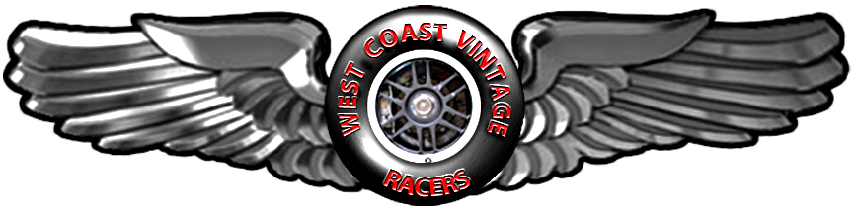
West Coast Vintage Racers
2018
Statement of Purpose Regarding: Driver Conduct and On Track Etiquette

Purpose: To provide a venue for people with competition cars who, for various reasons, no longer wish to participate in full competition events yet want to continue involvement in oval racing. Preservation of these cars in a racing environment is viewed as important to the sport and our club.

Driver Conduct: Vintage racing is NOT the same as competition with current cars who race for a paid purse. Although competitive in a sense, the primary purpose is NOT to win. If wining is your attitude then you need to be competing in regular paid purse oval racing. Vintage driving is expected to provide a safe and enjoyable environment for all participants and spectators. This requires recognizing that vintage grids include cars of many ages with great disparities in speed, corning, and braking capabilities. Drivers, as well, tend to possess widely varied experience and ability. Accordingly, drivers are expected to exercise great care, prudence, and courtesy in traffic and while passing. The slowest car and driver has as much right to be on the track as the fastest, and all drivers must conduct themselves accordingly and make room for each other.

On Track Racing Etiquette

Start of the Race: The inside pole has the right to set the pace of the start of the race. However consideration of the rest of the field and engines to start at a brisk pace. The outside car has the responsibility to maintain the speed of the pole car.

After Green Flag: Once the green flag is given for the start, cars are to maintain their position through turns 1 and 2. Passing may start on the back straight. This gives a chance for the field to sort out.

Passing Cars: Try to hold a constant line. If you are all over the track it is harder for faster cars to pass cleanly. This leads to accidents, damaged cars, hot tempers and bad feelings.

Passing on the inside: Passing by driving inside going into the turns is discouraged. If you can get side by side going down the straight then the inside car has the position and the slower car must give way. If you are not completely side by side then you must brake and let the other car move down and forward. Do not floor the throttle to achieve position.

Passing on the outside: If you are passing on the outside you must be completely around the slower car before pulling down in front of him. The car on the inside has the right to accelerate as hard as possible to prevent you from getting in front. He does not have the right to steer to the right in an attempt to block the pass.

Cars being passed: Maintain your line to allow for racing room for the faster car. Do not move up the track in an attempt to block the pass. Stay on the gas and keep to the inside.

Spin Outs: Spin outs are a normal consequence of racing and will happen due to a number of circumstances. However a spinning car shall not try to do a 360 and keep going. Spinning cars must stop and lock down. Doing a 360 causes accidents.

Car to Car Contact: Car to car contact is absolutely contrary to the sprit of vintage racing. Any dangerous driving will be penalized with exclusion fro the event or from the season. Remember this is open wheel racing and by it’s nature is dangerous. Hitting another car front to rear or wheel to wheel results in injured drivers and torn up cars.

Track Flagman: All flags must be obeyed. Yellow and red flags must be observed. Restarts will be single file starts. Flagman should be informed that if he sees any aggressive and/or unsafe driving he should immediately BLACK FLAG the offending driver.

Driving to Win: As stated in driver conduct the primary purpose in vintage racing is not to win. If you have the fasted car and feel you must win, at least wait until the last few laps to run away. The purpose of our club is to put on an entertaining show of racing old cars for the spectators

I ______________________________________________have read the West Coast Statement of Purpose, Driver Contact and on Track Racing Etiquette Rules. I agree to abide by these principles.

Signed__________________________________________
Date________________

Please sign and return this document to: WCVR
1805 SE Harold
Portland, Oregon 97202

